Errors:
Debug 1:

aicha@aicha-Vostro-3500:/media/aicha/DATA/Technique_Optimisation/TOP_LBM/simu_simple_LBM$ make clean
rm -f main.o lbm_phys.o lbm_init.o lbm_struct.o lbm_comm.o lbm_config.o
rm -f lbm display
aicha@aicha-Vostro-3500:/media/aicha/DATA/Technique_Optimisation/TOP_LBM/simu_simple_LBM$ make
mpicc -Wall -g -c -o main.o main.c
mpicc -Wall -g -c -o lbm_phys.o lbm_phys.c
mpicc -Wall -g -c -o lbm_init.o lbm_init.c
mpicc -Wall -g -c -o lbm_struct.o lbm_struct.c
mpicc -Wall -g -c -o lbm_comm.o lbm_comm.c
mpicc -Wall -g -c -o lbm_config.o lbm_config.c
mpicc -Wall -g -o lbm main.o lbm_phys.o lbm_init.o lbm_struct.o lbm_comm.o lbm_config.o -lm
gcc -Wall -g -o display display.c
aicha@aicha-Vostro-3500:/media/aicha/DATA/Technique_Optimisation/TOP_LBM/simu_simple_LBM$ ./lbm
=================== CONFIG ===================
iterations = 100
width = 800
height = 160
obstacle_r = 17.000000
obstacle_x = 161.000000
obstacle_y = 83.000000
reynolds = 100.000000
reynolds = 100.000000
inflow_max_velocity = 0.100000
output_filename = resultat.raw
write_interval = 10
------------ Derived parameters --------------
kinetic_viscosity = 0.034000
relax_parameter = 1.661130
==============================================
RANK 0 ( LEFT -1 RIGHT -1 TOP -1 BOTTOM -1 CORNER -1, -1, -1, -1 ) ( POSITION 0 0 ) (WH 802 162 )
[aicha-Vostro-3500:17282] *** Process received signal ***
[aicha-Vostro-3500:17282] Signal: Segmentation fault (11)
[aicha-Vostro-3500:17282] Signal code: Address not mapped (1)
[aicha-Vostro-3500:17282] Failing at address: (nil)
[aicha-Vostro-3500:17282] [ 0] /lib/x86_64-linux-gnu/libc.so.6(+0x430c0)[0x7fdf10a170c0]
[aicha-Vostro-3500:17282] [ 1] ./lbm(+0x2b55)[0x55db72ceeb55]
[aicha-Vostro-3500:17282] [ 2] ./lbm(+0x2e32)[0x55db72ceee32]
[aicha-Vostro-3500:17282] [ 3] ./lbm(+0x19ef)[0x55db72ced9ef]
[aicha-Vostro-3500:17282] [ 4] /lib/x86_64-linux-gnu/libc.so.6(__libc_start_main+0xf3)[0x7fdf109f80b3]
[aicha-Vostro-3500:17282] [ 5] ./lbm(+0x138e)[0x55db72ced38e]
[aicha-Vostro-3500:17282] *** End of error message ***
Segmentation fault (core dumped)
aicha@aicha-Vostro-3500:/media/aicha/DATA/Technique_Optimisation/TOP_LBM/simu_simple_LBM$ gdb ./lbm
GNU gdb (Ubuntu 9.2-0ubuntu1~20.04) 9.2
Copyright (C) 2020 Free Software Foundation, Inc.
License GPLv3+: GNU GPL version 3 or later <http://gnu.org/licenses/gpl.html>
This is free software: you are free to change and redistribute it.
There is NO WARRANTY, to the extent permitted by law.
Type "show copying" and "show warranty" for details.
This GDB was configured as "x86_64-linux-gnu".
Type "show configuration" for configuration details.
For bug reporting instructions, please see:
<http://www.gnu.org/software/gdb/bugs/>.
Find the GDB manual and other documentation resources online at:
<http://www.gnu.org/software/gdb/documentation/>.

For help, type "help".
Type "apropos word" to search for commands related to "word"...
Reading symbols from ./lbm...
(gdb) run
Starting program: /media/aicha/DATA/Technique_Optimisation/TOP_LBM/simu_simple_LBM/lbm
[Thread debugging using libthread_db enabled]
Using host libthread_db library "/lib/x86_64-linux-gnu/libthread_db.so.1".
[Detaching after fork from child process 17305]
[New Thread 0x7ffff7841700 (LWP 17310)]
[New Thread 0x7ffff6ea5700 (LWP 17311)]
=================== CONFIG ===================
iterations = 100
width = 800
height = 160
obstacle_r = 17.000000
obstacle_x = 161.000000
obstacle_y = 83.000000
reynolds = 100.000000
reynolds = 100.000000
inflow_max_velocity = 0.100000
output_filename = resultat.raw
write_interval = 10
------------ Derived parameters --------------
kinetic_viscosity = 0.034000
relax_parameter = 1.661130
==============================================
RANK 0 ( LEFT -1 RIGHT -1 TOP -1 BOTTOM -1 CORNER -1, -1, -1, -1 ) ( POSITION 0 0 ) (WH 802 162 )

Thread 1 "lbm" received signal SIGSEGV, Segmentation fault.
0x0000555555556b55 in setup_init_state_global_poiseuille_profile (mesh=0x7fffffffdc10, mesh_type=0x7fffffffdc40, mesh_comm=0x7fffffffdc50) at lbm_init.c:85
85 Mesh_get_cell(mesh, i, j)[k] = compute_equilibrium_profile(v,density,k);
(gdb) print mesh
$1 = (Mesh *) 0x7fffffffdc10
(gdb) print *mesh
$2 = {cells = 0x0, width = 802, height = 162}
(gdb) list Mesh_get_cell
110 /******************* FUNCTION *********************/
111 /**
112 * Fonction à utiliser pour récupérer une cellule du maillage en fonction de ses coordonnées.
113 **/
114 static inline lbm_mesh_cell_t Mesh_get_cell( const Mesh *mesh, int x, int y)
115 {
116 return &mesh->cells[ (x * mesh->height + y) * DIRECTIONS ];
117 }
118
119 /******************* FUNCTION *********************/
(gdb) backtrace
#0 0x0000555555556b55 in setup_init_state_global_poiseuille_profile (mesh=0x7fffffffdc10, mesh_type=0x7fffffffdc40, mesh_comm=0x7fffffffdc50) at lbm_init.c:85
#1 0x0000555555556e32 in setup_init_state (mesh=0x7fffffffdc10, mesh_type=0x7fffffffdc40, mesh_comm=0x7fffffffdc50) at lbm_init.c:156
#2 0x00005555555559ef in main (argc=1, argv=0x7fffffffdea8) at main.c:160

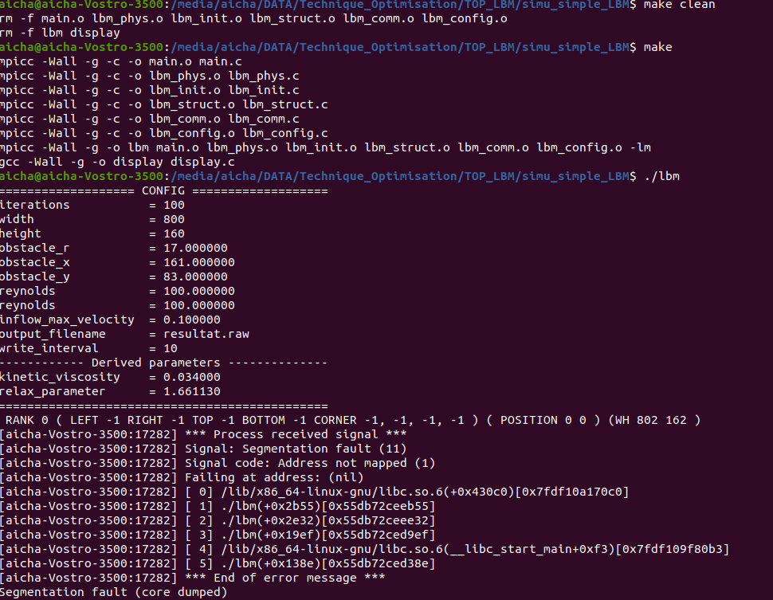

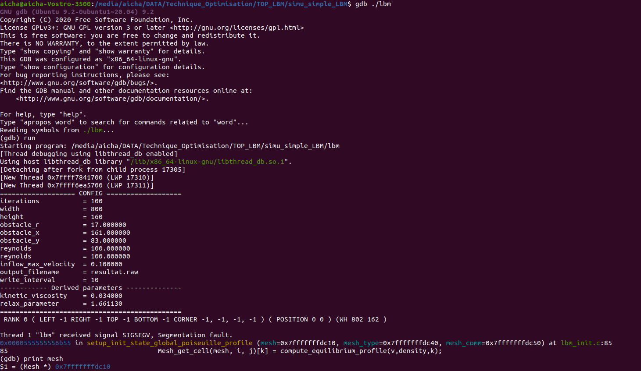
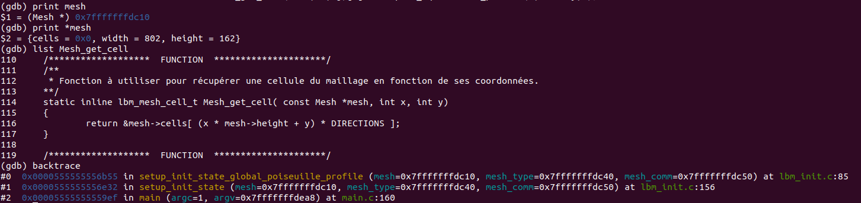

//alloc cells memory
//mesh->cells = malloc( width * height * DIRECTIONS * sizeof( double ) );
mesh->cells = NULL;

After correction:

aicha@aicha-Vostro-3500:/media/aicha/DATA/Technique_Optimisation/TOP_LBM/simu_simple_LBM$ make
mpicc -Wall -g -c -o lbm_struct.o lbm_struct.c
mpicc -Wall -g -o lbm main.o lbm_phys.o lbm_init.o lbm_struct.o lbm_comm.o lbm_config.o -lm
aicha@aicha-Vostro-3500:/media/aicha/DATA/Technique_Optimisation/TOP_LBM/simu_simple_LBM$ ./lbm
=================== CONFIG ===================
iterations = 100
width = 800
height = 160
obstacle_r = 17.000000
obstacle_x = 161.000000
obstacle_y = 83.000000
reynolds = 100.000000
reynolds = 100.000000
inflow_max_velocity = 0.100000
output_filename = resultat.raw
write_interval = 10
------------ Derived parameters --------------
kinetic_viscosity = 0.034000
relax_parameter = 1.661130
==============================================
RANK 0 ( LEFT -1 RIGHT -1 TOP -1 BOTTOM -1 CORNER -1, -1, -1, -1 ) ( POSITION 0 0 ) (WH 802 162 )
Progress [ 1 / 100]
Progress [ 2 / 100]
Progress [ 3 / 100]
Progress [ 4 / 100]
Progress [ 5 / 100]
Progress [ 6 / 100]

→ since we are trying to debug the code with fprintf on stderr, the printing of the progress should be also with fprintf on stderr.

//save step
if ( i % WRITE_STEP_INTERVAL == 0 && lbm_gbl_config.output_filename != NULL )
save_frame_all_domain(fp, &mesh, &temp_render );
fprintf(stderr, "rank %d: Before end of loop \n", rank);
}

if( rank == RANK_MASTER && fp != NULL)
{
close_file(fp);
}

fprintf(stderr, "rank %d: After closing the file \n", rank);

screenshots:
The prob is in the closing file with rank 0 (RANK_MASTER), I investigated the close file function and noticed the mpi barrier while the function is executed on only one proc.

* in the main.c, need to comment MPI_Barrier

void close_file(FILE* fp){
//wait all before closing
//MPI_Barrier(MPI_COMM_WORLD);
//close file
fclose(fp);
}

